**TABLE CREATION :**

1. **Subject Table:**

create table subject (subject_no number(10) constraint subject_subject_no_pk primary key ,subject_name varchar(32) not null);

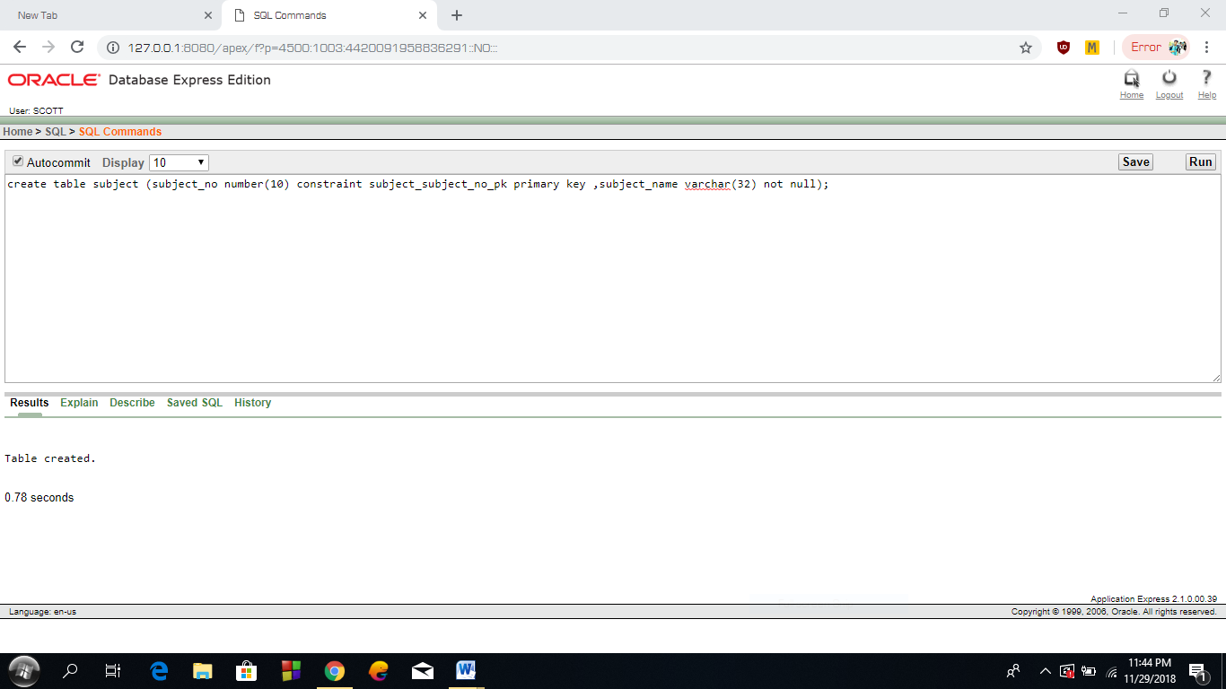

1. **Teacher Table:**

create table teacher (teacher_id number(10) constraint teacher_teacher_id_pk primary key,name varchar(20) not null,designation varchar(32),marks float);

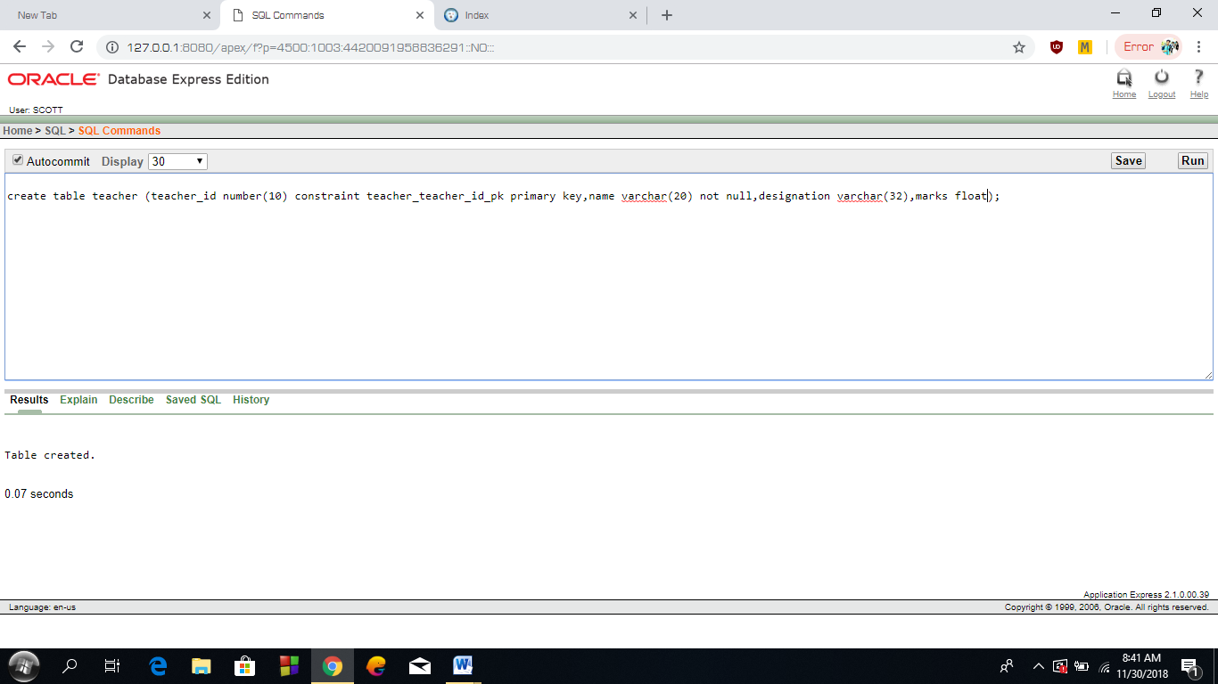

**3. Student Table:**

create table student( student_id number(10) constraint student_student_id_pk primary key,s_name varchar(30) ,date_of_birth date not null,subject_no constraint student_student_id_fk references subject(subject_no) );

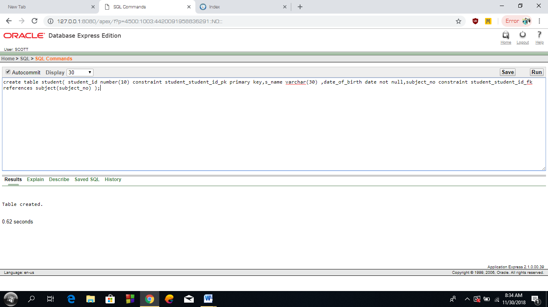

**4. Question Table:**

create table question(qus_id number(10) constraint question_qus_id_pk primary key,teacher_id number(10) constraint question_teacher_id_tfk references teacher(teacher_id),create_date date not null,subject_no number(10) constraint question_subject_no_sfk references subject(subject_no));



**5. Answer Table:**

create table answer(ans_id number(10) constraint answer_ans_id_pk primary key,student_id number(10) constraint answer_student_id_fk references student(student_id),correct_ans number(2), subject_no number(10) constraint answer_subject_no_fk references subject(subject_no),qus_id number(10) constraint answer_qus_id_fk references question(qus_id));

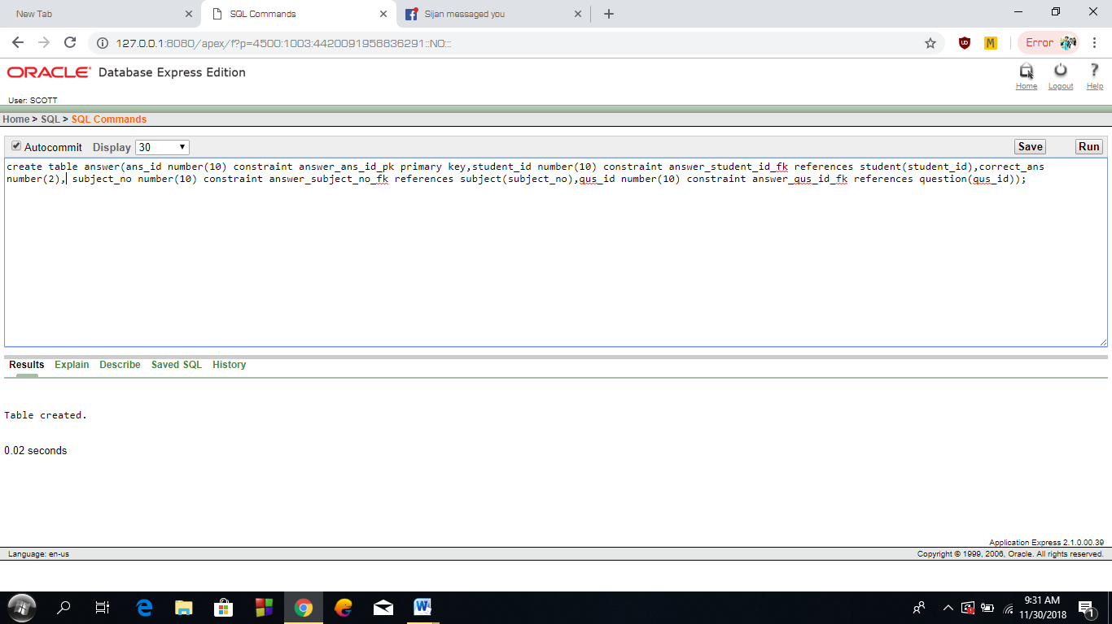

**6.Exam Table:**

create table exam(exam_id number(10) constraint exam_exam_id_pk primary key,exam_date date not null,total_marks float not null,marks float default (0) not null,subject_no number(10) constraint exam_subject_id_fk references subject(subject_no));

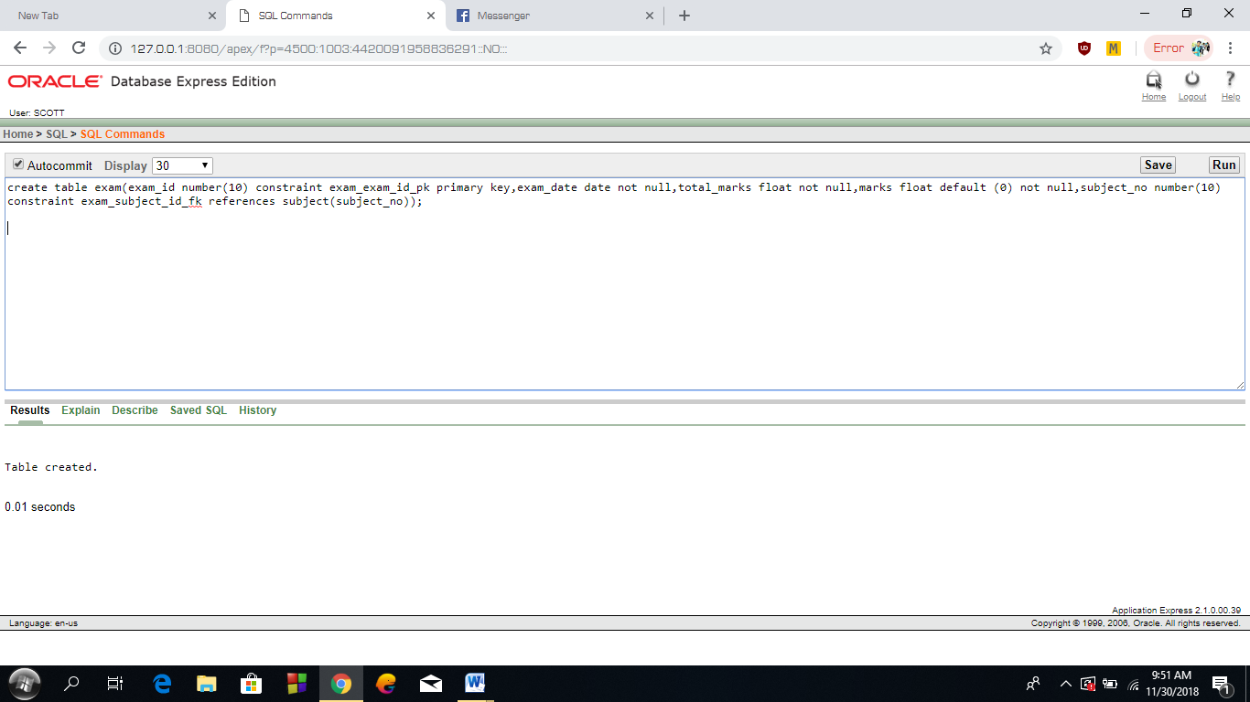

**DATA INSERTION & SHOWING TABLE:**

**1. Subject Table:**

insert into subject(subject_no ,subject_name ) values (01,'DATA BASE');

insert into subject(subject_no ,subject_name ) values (02,'DATA STRUCTURE');

insert into subject(subject_no ,subject_name ) values (03,'MATHEMATICS');

insert into subject(subject_no ,subject_name ) values (04,'ELECTRICAL CIRCUIT');

insert into subject(subject_no ,subject_name ) values (05,'COMPUTER FUNDAMENTAL');

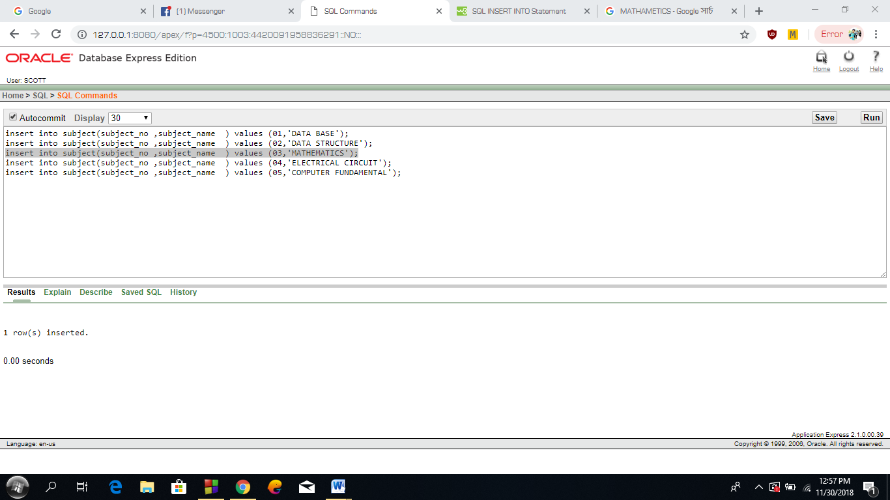

select * from subject;

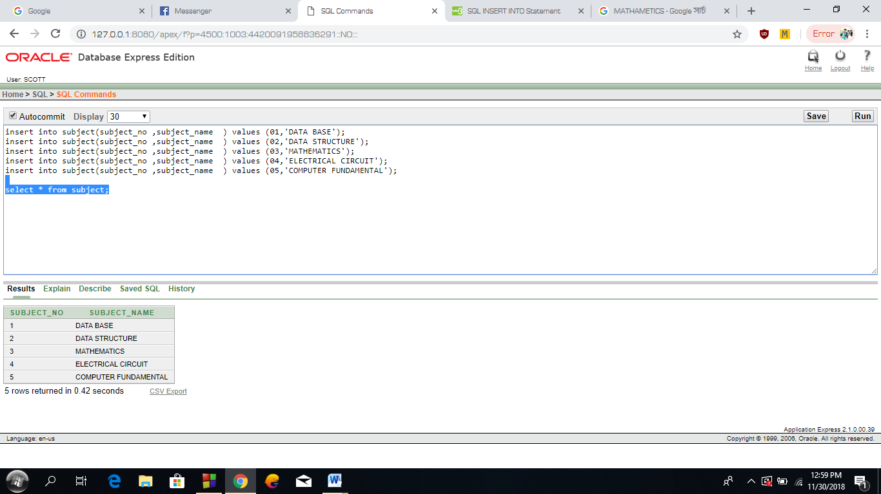

**2. Teacher Table:**

insert into teacher(teacher_id,name,designation,marks) values(01,'U','LECTURER',78);

insert into teacher(teacher_id,name,designation,marks) values(02,'V','PROFESSOR',82);

insert into teacher(teacher_id,name,designation,marks) values(03,'X','LECTURER',91);

insert into teacher(teacher_id,name,designation,marks) values(04,'Y','ASSIS PROF',71);

insert into teacher(teacher_id,name,designation,marks) values(05,'Z','ASSIS PROF',88);

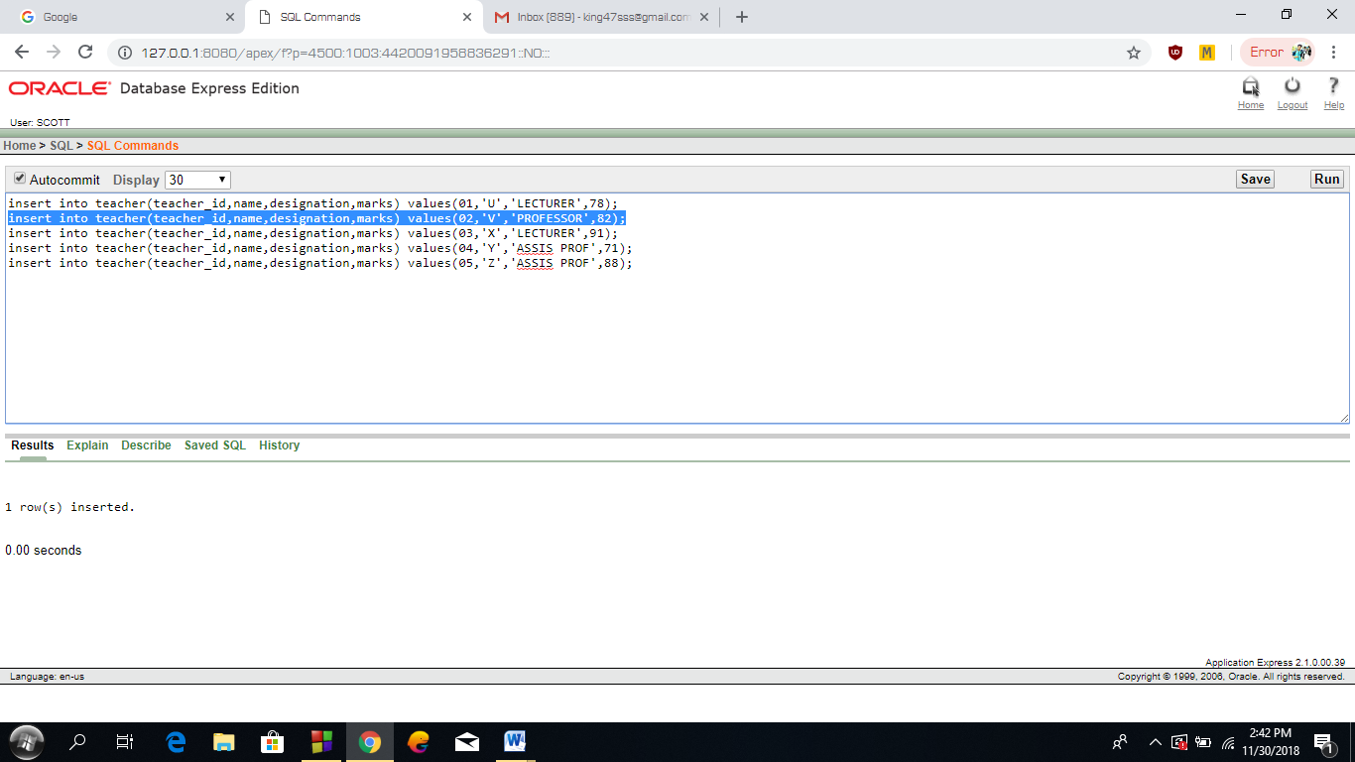

select * from teacher;

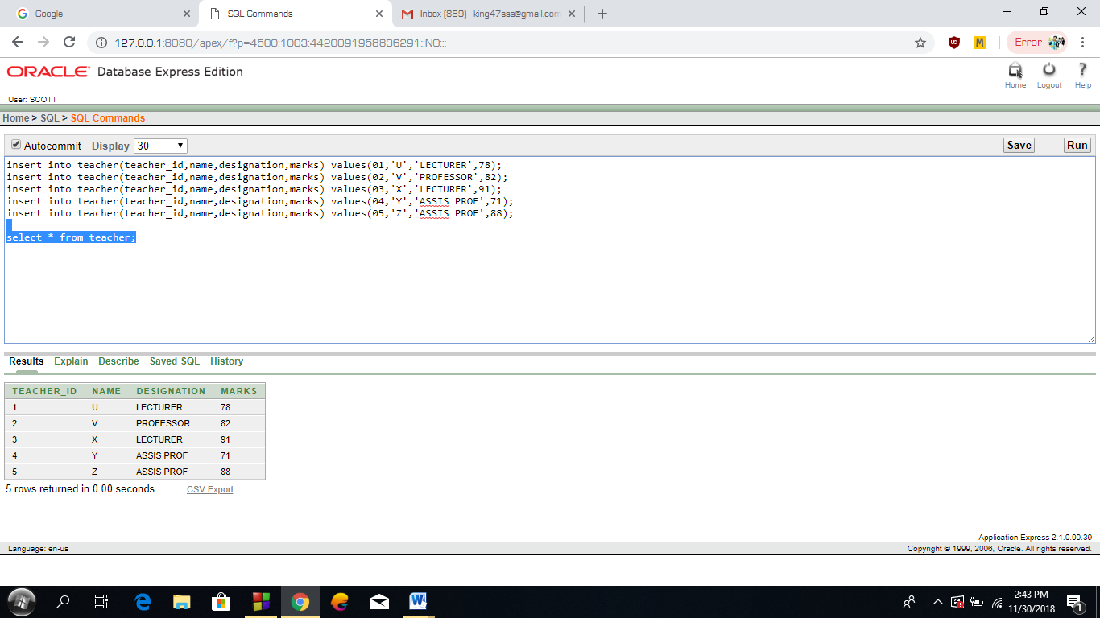

**3. Student Table:**

insert into student(student-id,s-name,date-of-birth,subject-no) values (01,'A','7-jun-97',02);

insert into student(student-id,s-name,date-of-birth,subject-no) values (02,'B','12-jul-98',01);

insert into student(student-id,s-name,date-of-birth,subject-no) values (03,'C','23-feb-99',05);

insert into student(student-id,s-name,date-of-birth,subject-no) values (04,'D','1-aug-97',04);

insert into student(student-id,s-name,date-of-birth,subject-no) values (05,'E','3-jan-96',04);

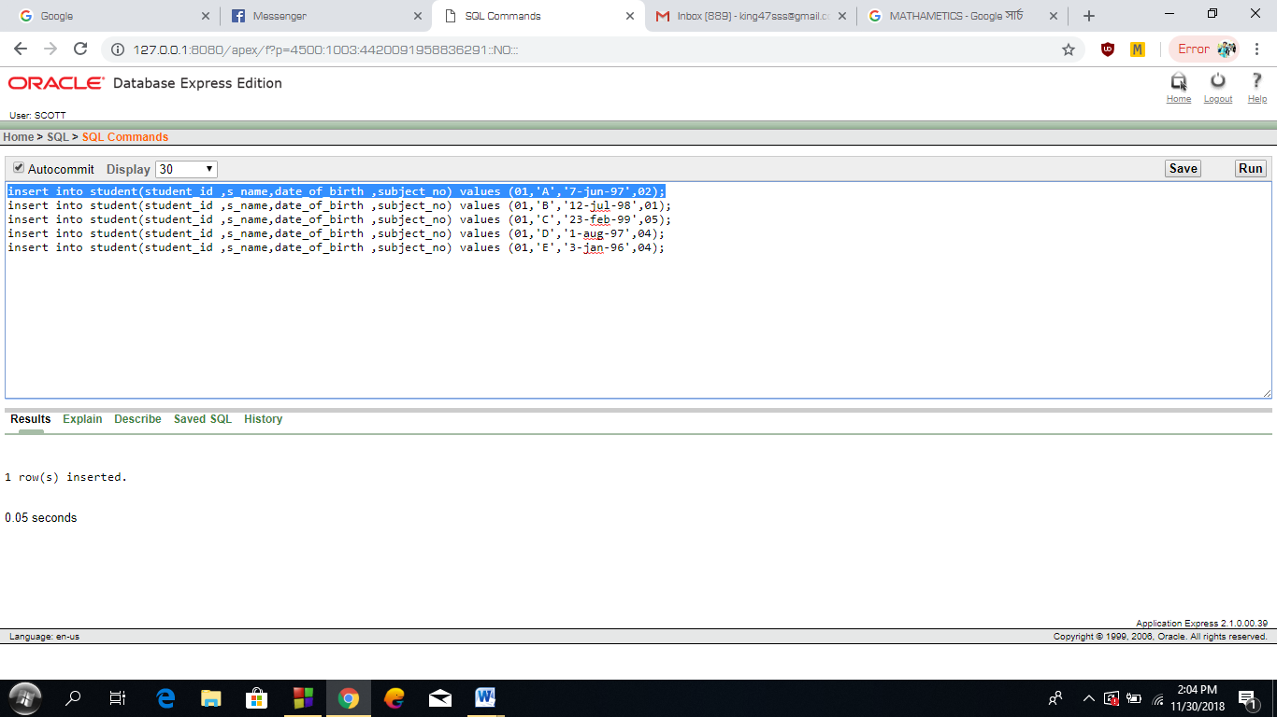

select * from student;

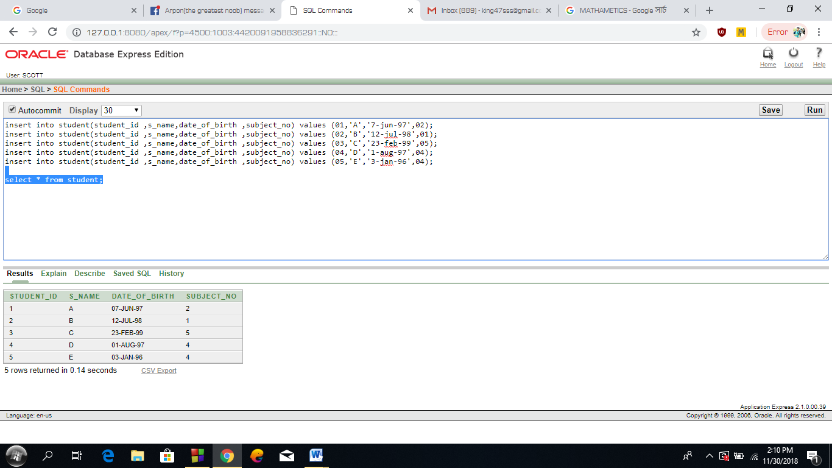

**4. Question Table:**

insert into question(qus_id,teacher_id,create_date,subject_no) values ('01','01','7-aug-18',02);

insert into question(qus_id,teacher_id,create_date,subject_no) values ('02','04','13-aug-18',05);

insert into question(qus_id,teacher_id,create_date,subject_no) values ('03','03','10-aug-18',01);

insert into question(qus_id,teacher_id,create_date,subject_no) values ('04','02','4-aug-18',04);

insert into question(qus_id,teacher_id,create_date,subject_no) values ('05','05','6-aug-18',03);

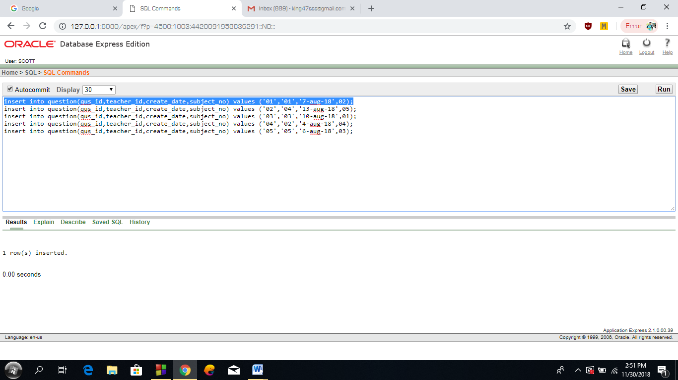

select * from question;

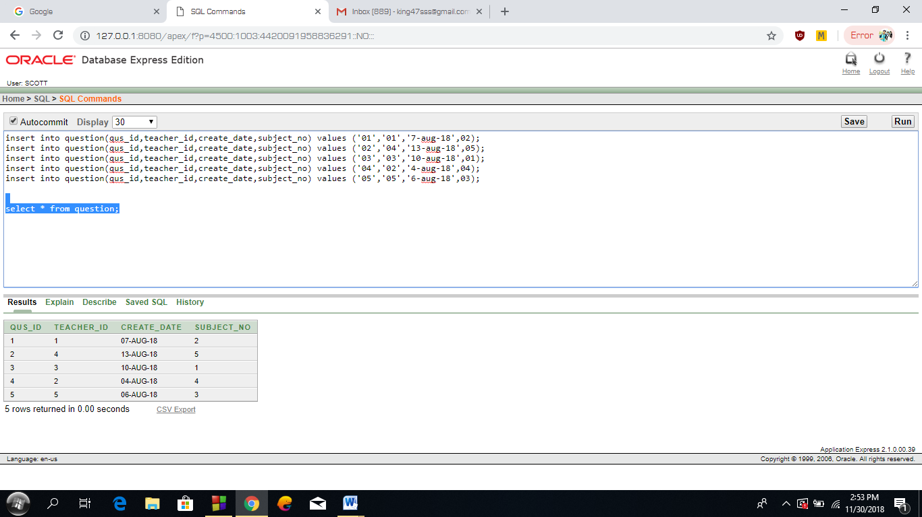

**5. Answer Table:**

insert into answer(ans_id ,student_id,correct_Ans,subject_no,qus_id) values('01','04','3','04','01');

insert into answer(ans_id ,student_id,correct_Ans,subject_no,qus_id) values('02','03','4','02','05');

insert into answer(ans_id ,student_id,correct_Ans,subject_no,qus_id) values('03','05','2','05','04');

insert into answer(ans_id ,student_id,correct_Ans,subject_no,qus_id) values('04','02','0','03','02');

insert into answer(ans_id ,student_id,correct_Ans,subject_no,qus_id) values('05','01','5','01','03');

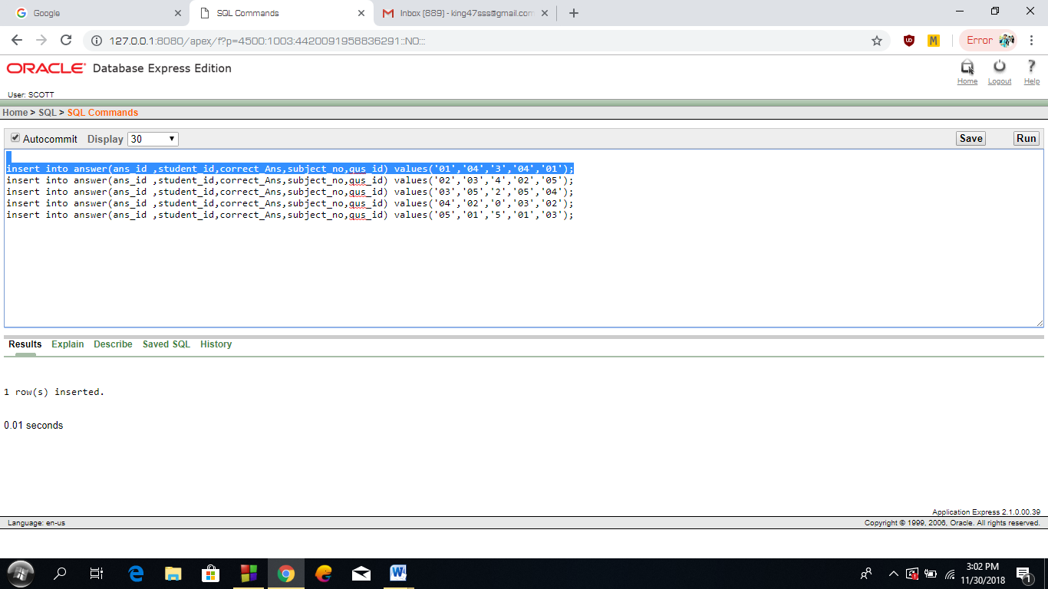

select * from answer;

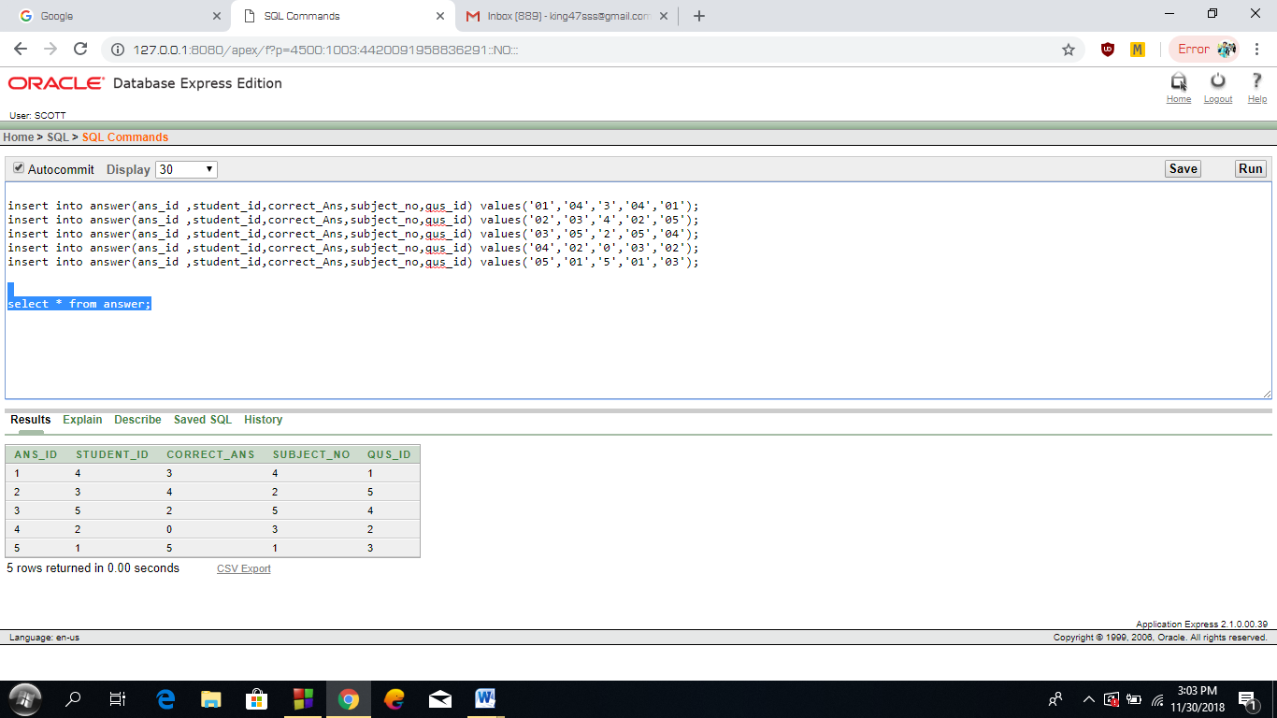

**6.Exam Table:**

insert into exam(exam_id,exam_date ,total_marks, subject_no,marks) values(01,'1-sep-18',100,02,80);

insert into exam(exam_id,exam_date ,total_marks, subject_no,marks) values(02,'3-sep-18',80,01,77);

insert into exam(exam_id,exam_date ,total_marks, subject_no,marks) values(03,'5-sep-18',75,04,69);

insert into exam(exam_id,exam_date ,total_marks, subject_no,marks) values(04,'7-sep-18',80,03,71);

insert into exam(exam_id,exam_date ,total_marks, subject_no,marks) values(05,'9-sep-18',85,05,73);

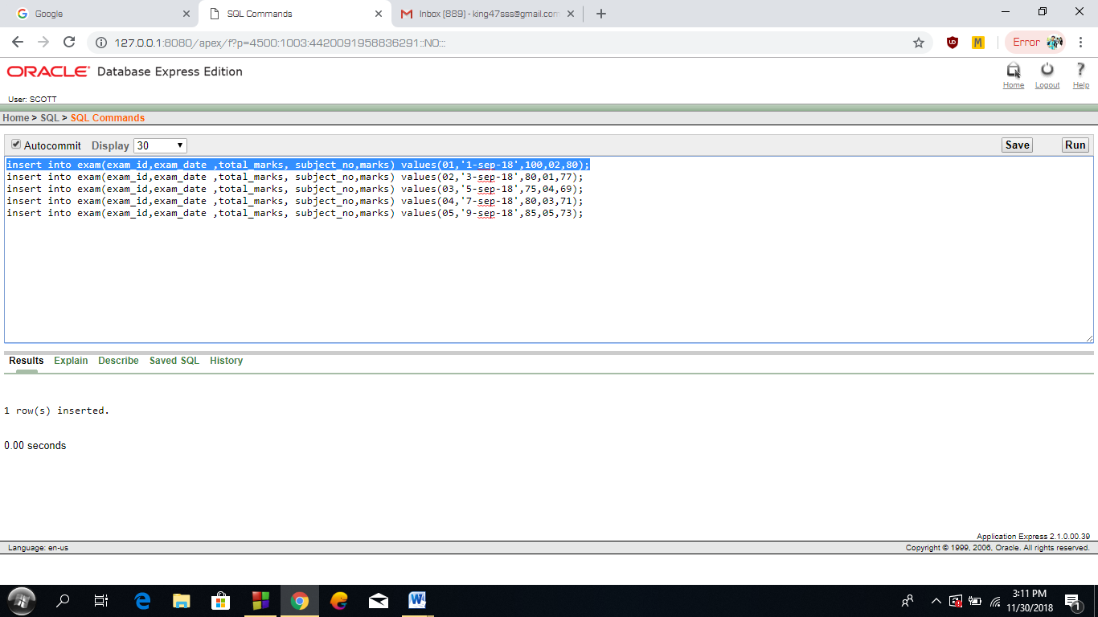

select * from exam;

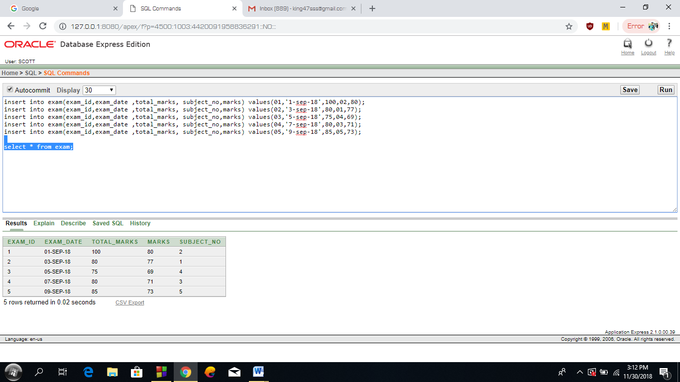

**JOINING:**

**1.** Find the subject name along with their total marks?(join)

select total_marks,subject_name from subject s,exam e where e.subject_no=s.subject_no;

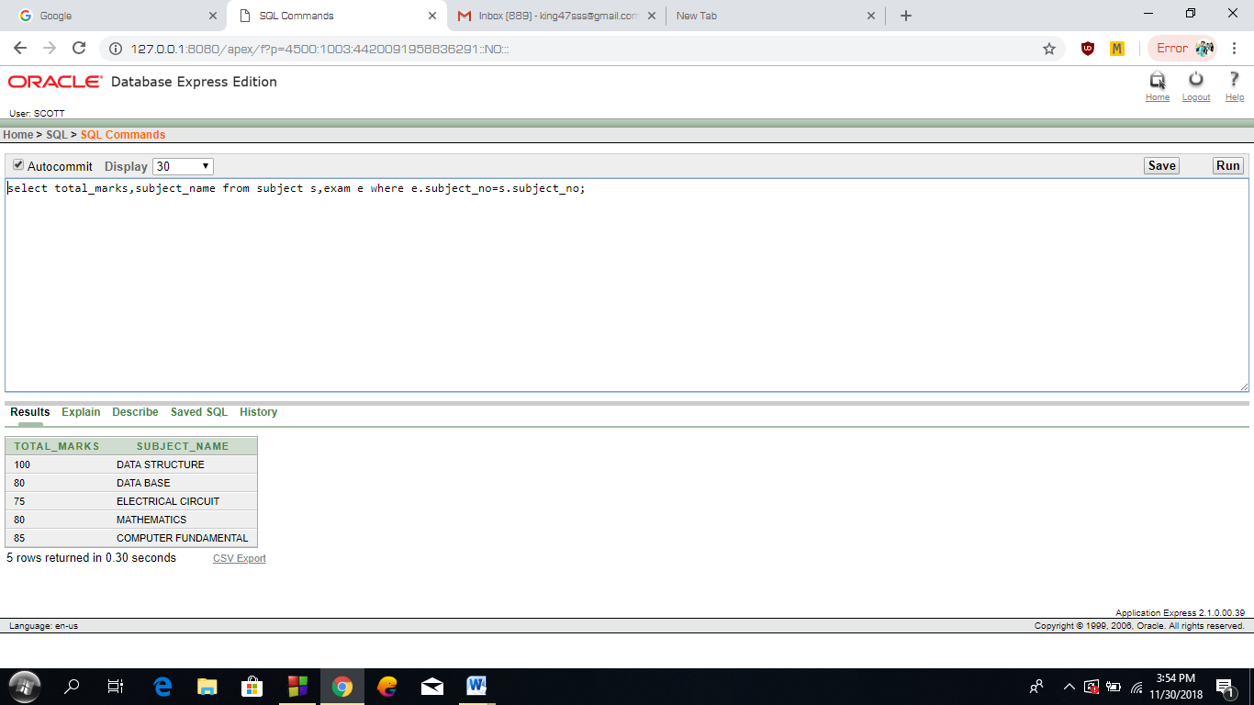

**2.** Show the teacher name with his or her question id?(join)

select t.name,q.qus_id from teacher t, question q where t.teacher_id=q.teacher_id;

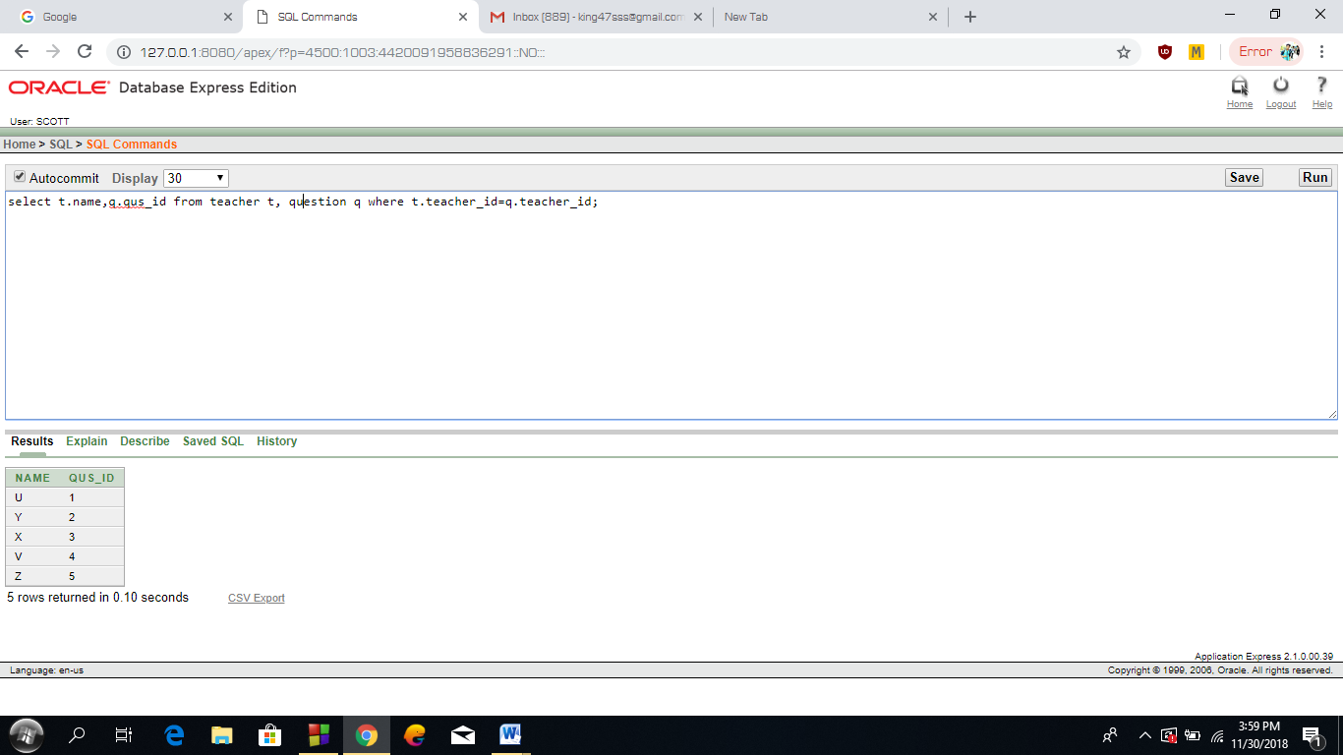

**3.** Find the teacher who created the question no 04 .(join)

select name from question q,teacher t where t.teacher_id=q.teacher_id and qus_id=04;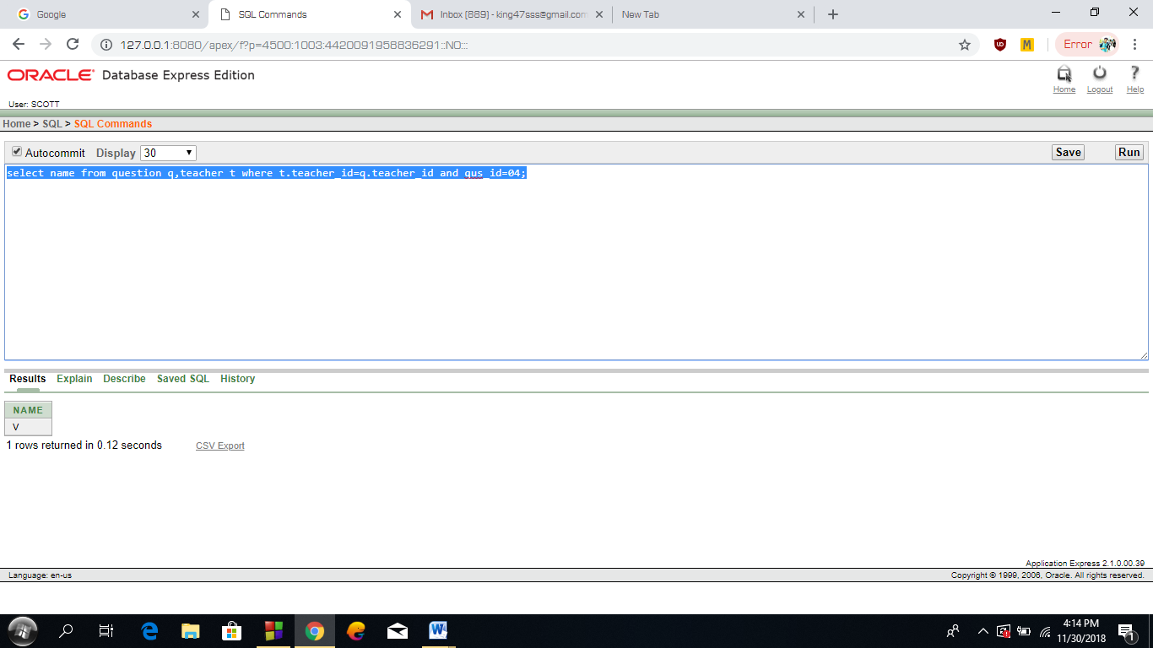 **4.** Show the id and number of correct answers given by student name C;

select s.student_id,correct_ans from answer a,student s where s.student_id=a.student_id and s_name='C' ;

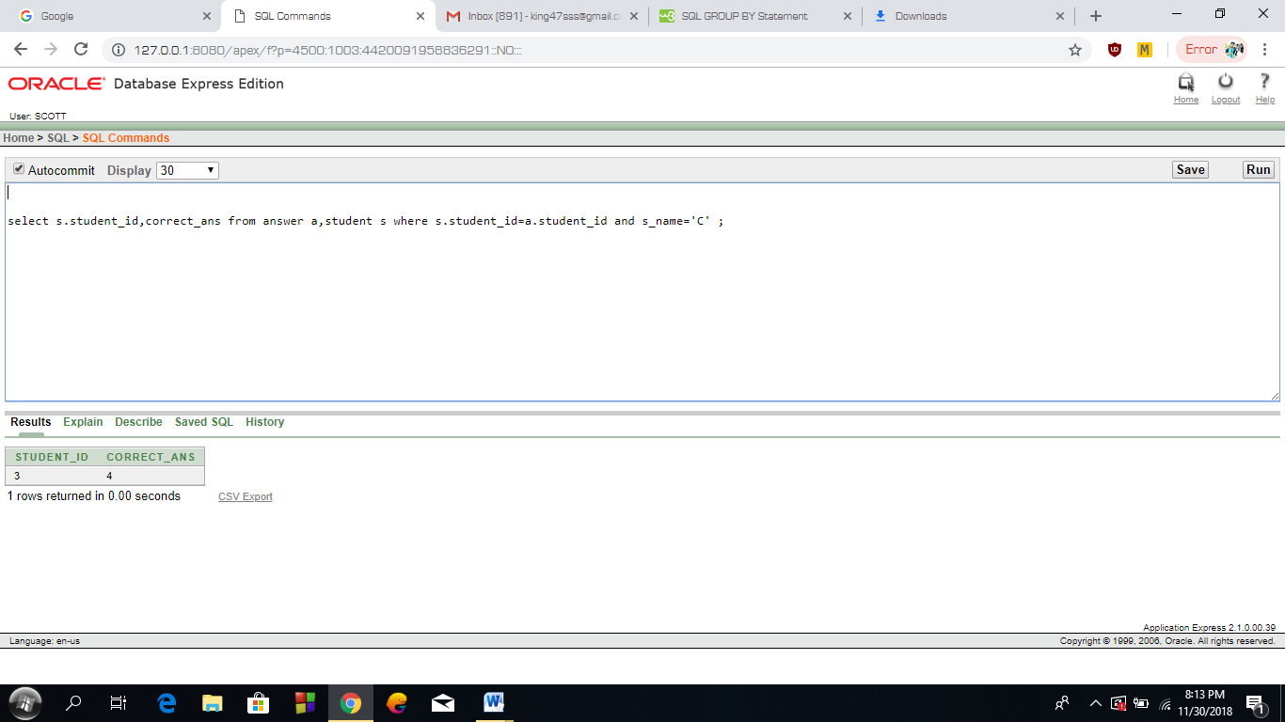

**SUB-QUERY:**

**1.** Find the teacher id where designation is same as ‘Y’?

select teacher_id from teacher where Designation=(select designation from teacher where name='Y');

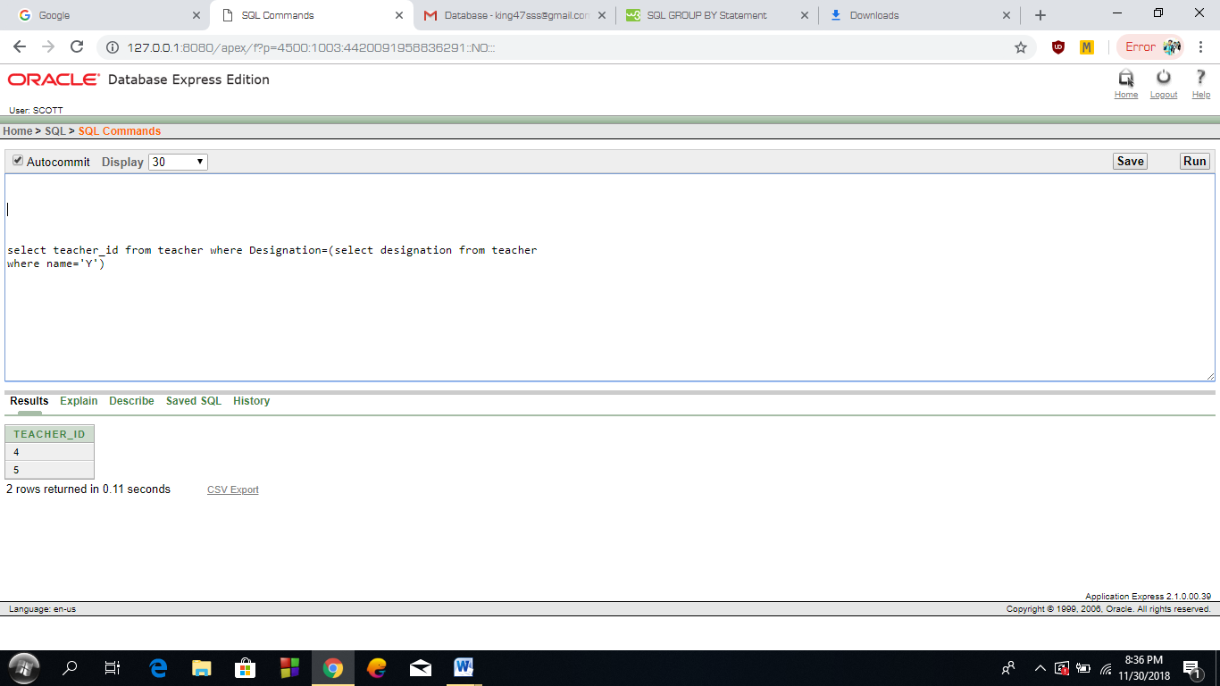

**2.** Find student name where date_of_birth is greater than ’A’?

select s_name from student where date_of_birth >(select date_of_birth from student where s_name='A');

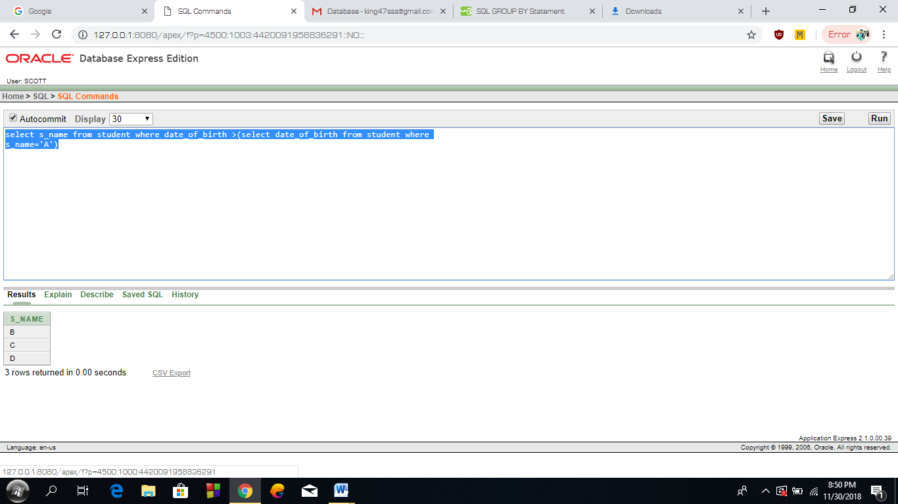

**3.** Show the name of the student who gave exam no 02;(sub)

select s_name from student where subject_no=(select subject_no from exam where exam_id='02');

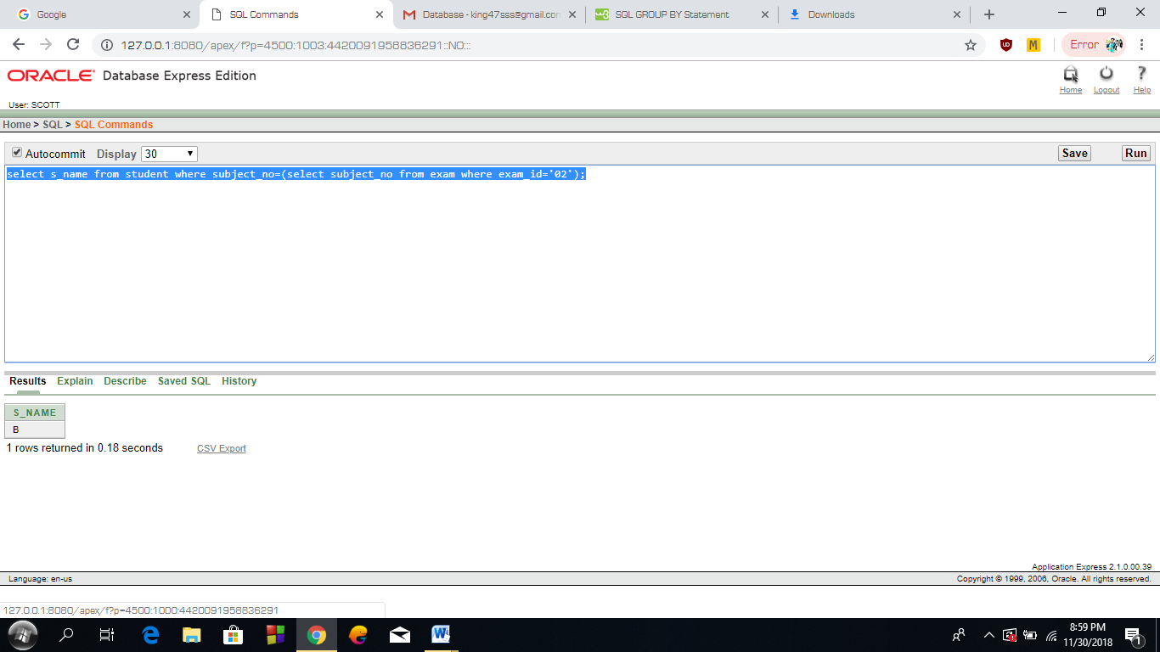

**4.** Show the name of the teachers who give more marks from all professors.(sub)

select name from teacher where marks >all (select max(marks) from teacher where designation='PROFESSOR' group by designation );

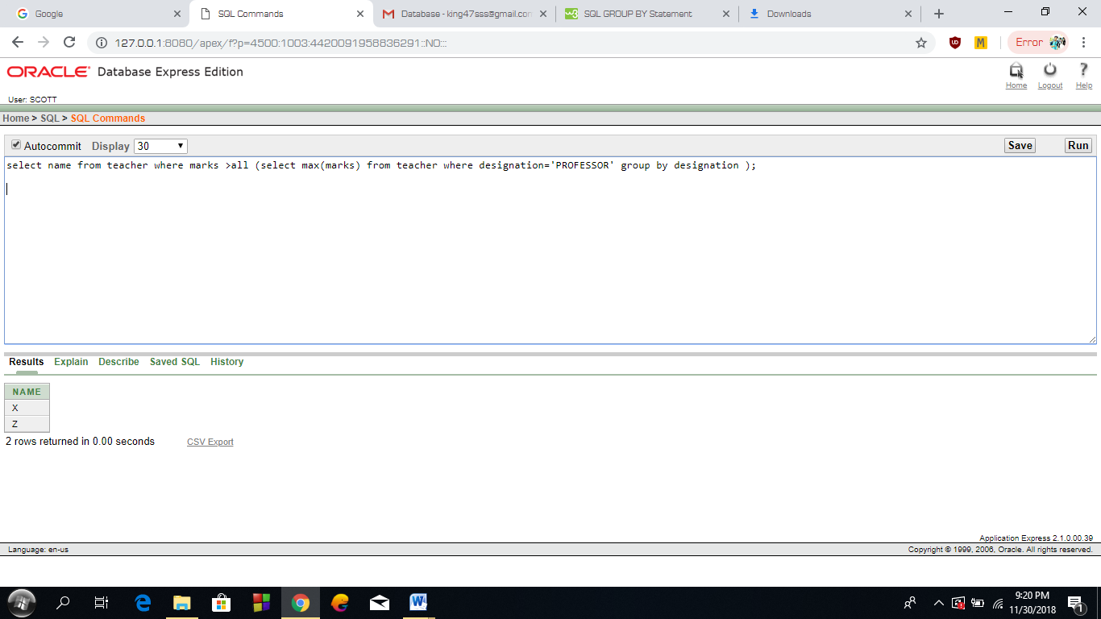

**ENABLE & DISABLE CONSTRAINTS:**

**DISABLE:**

Disable the constraint of teacher_id from question table.

alter table question disable constraint question_teacher_id_tfk ;

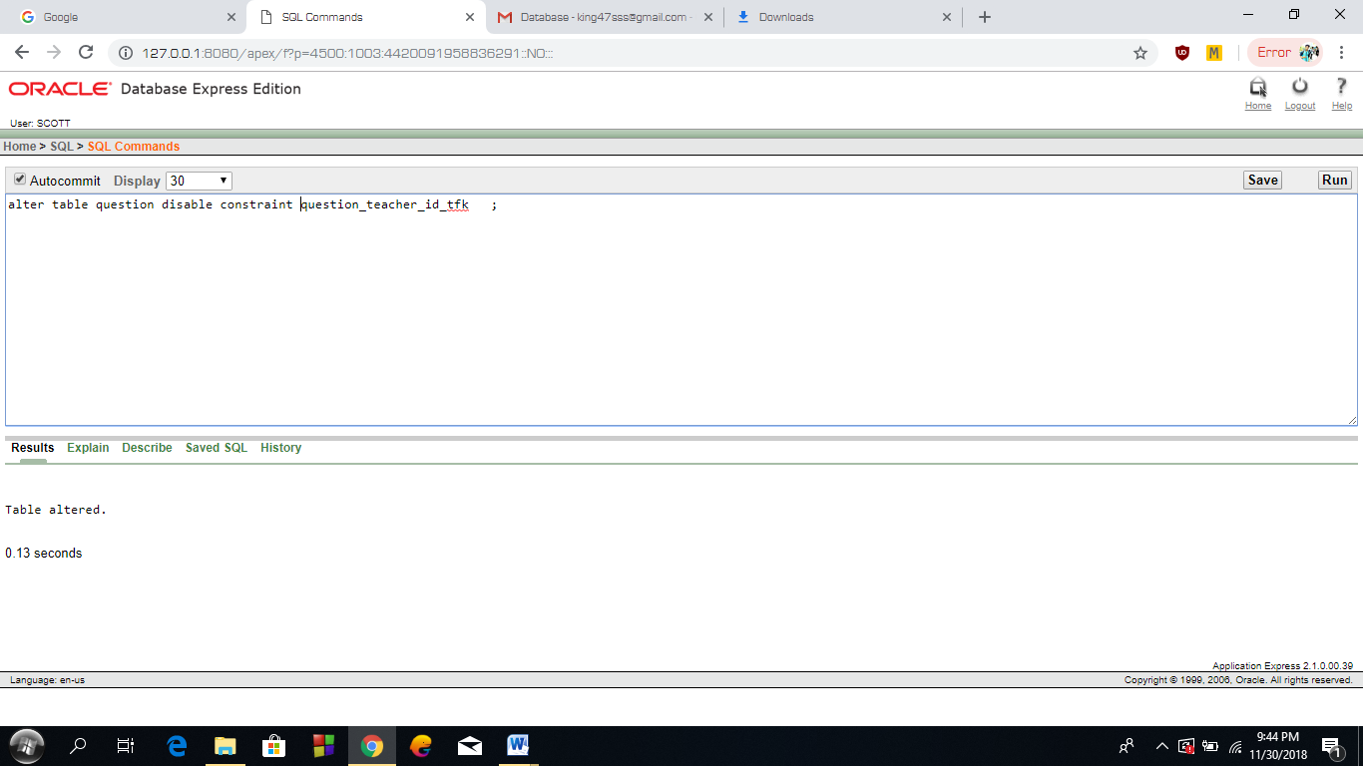

**ENABLE:**

Enable the constraint of teacher_id from question table.

alter table question enable constraint question_teacher_id_tfk;

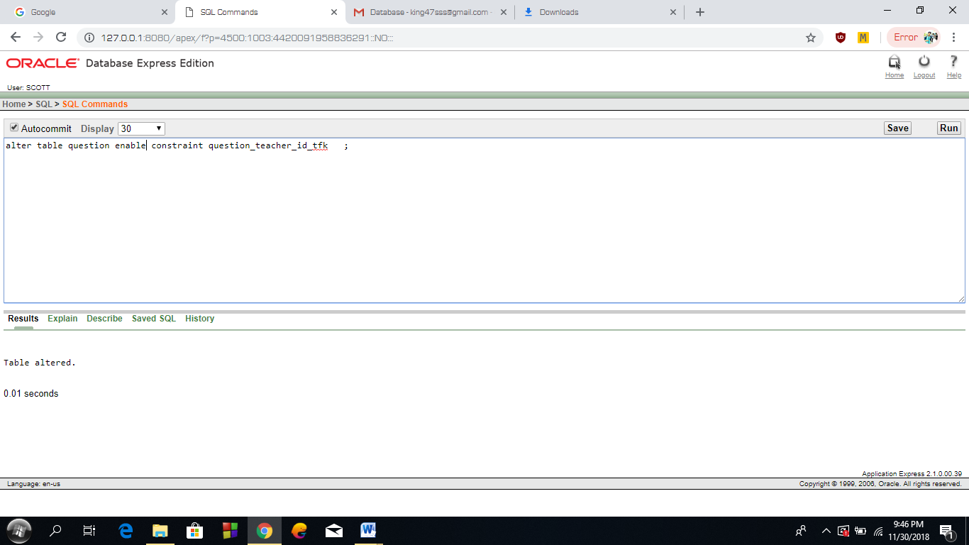

**INTRODUCTION TO DATABASE**

**PROJECT FALL 2018-19**

**PROJECT NAME: Examination Management System.**

**Course Teacher: Kawser Irom Rushee**

**GROUP MEMBERS**

**NAME - ID - SECTION**

**1. SIJAN,MD.AHOSAN HOSSAIN 18-37099-1 K2**

**2. SHAHORIAR,ARSHAD 18-37104-1 K2**

**3. FAHAD MOLLA 18-37548-1 K2**

**4.RAHMAN,MAHMUDUR 18-36452-1 L**

### Database Project Report-Part 3